Modificando el index

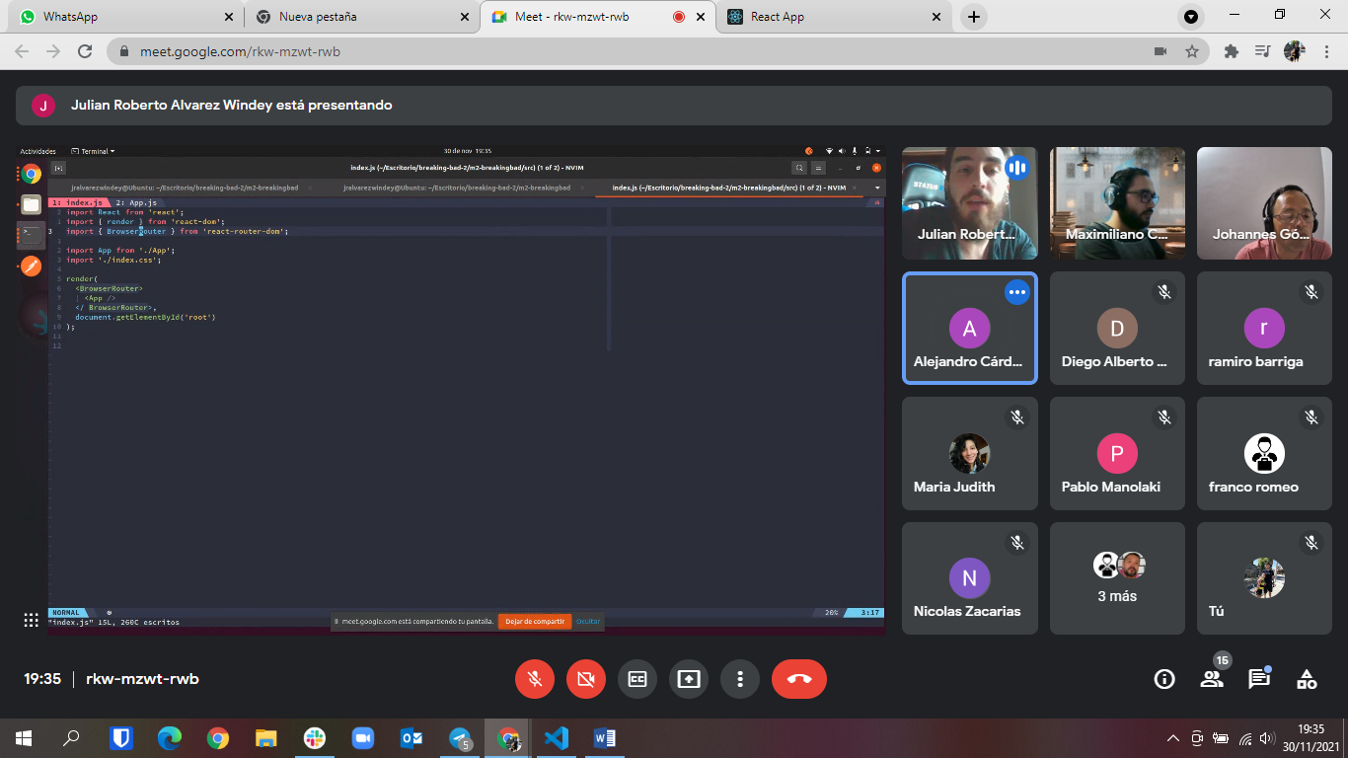

Modificando la APP

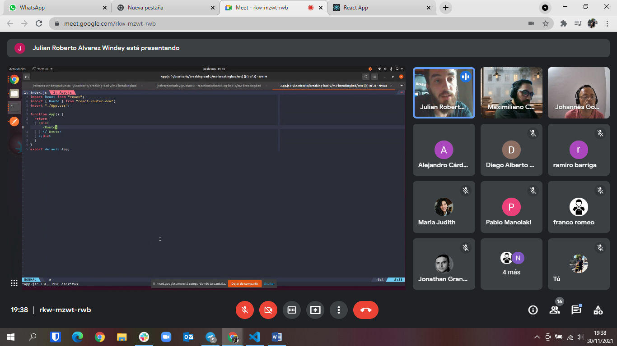

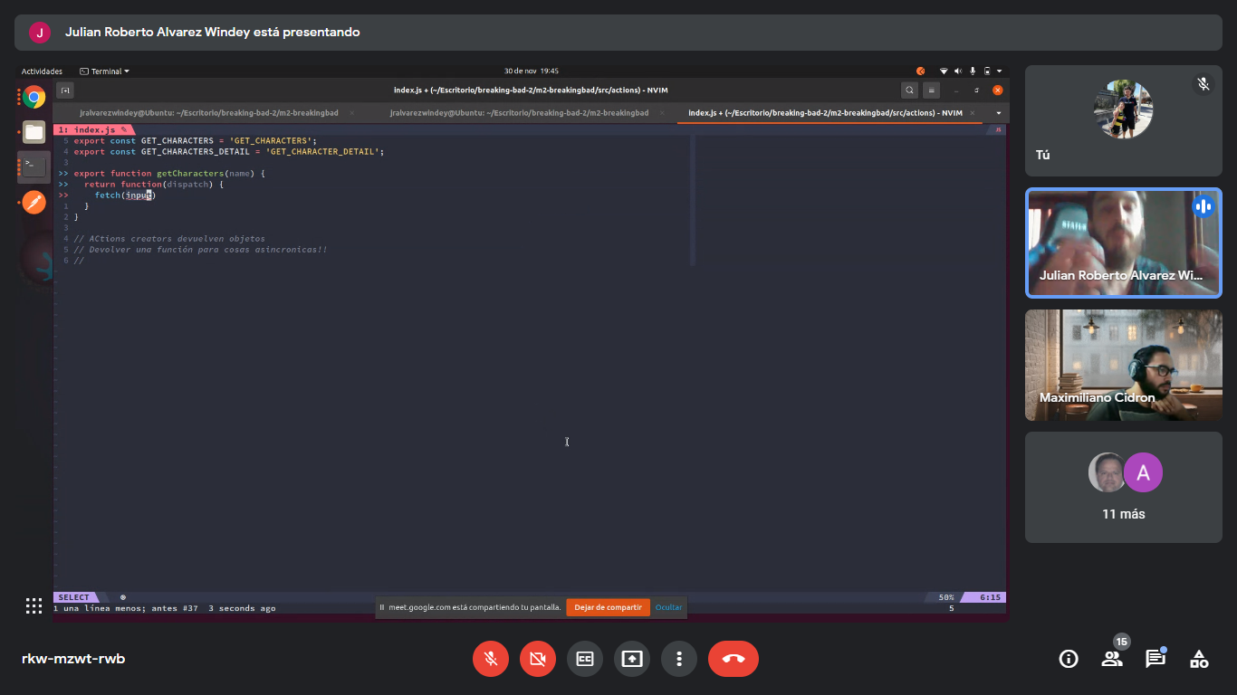

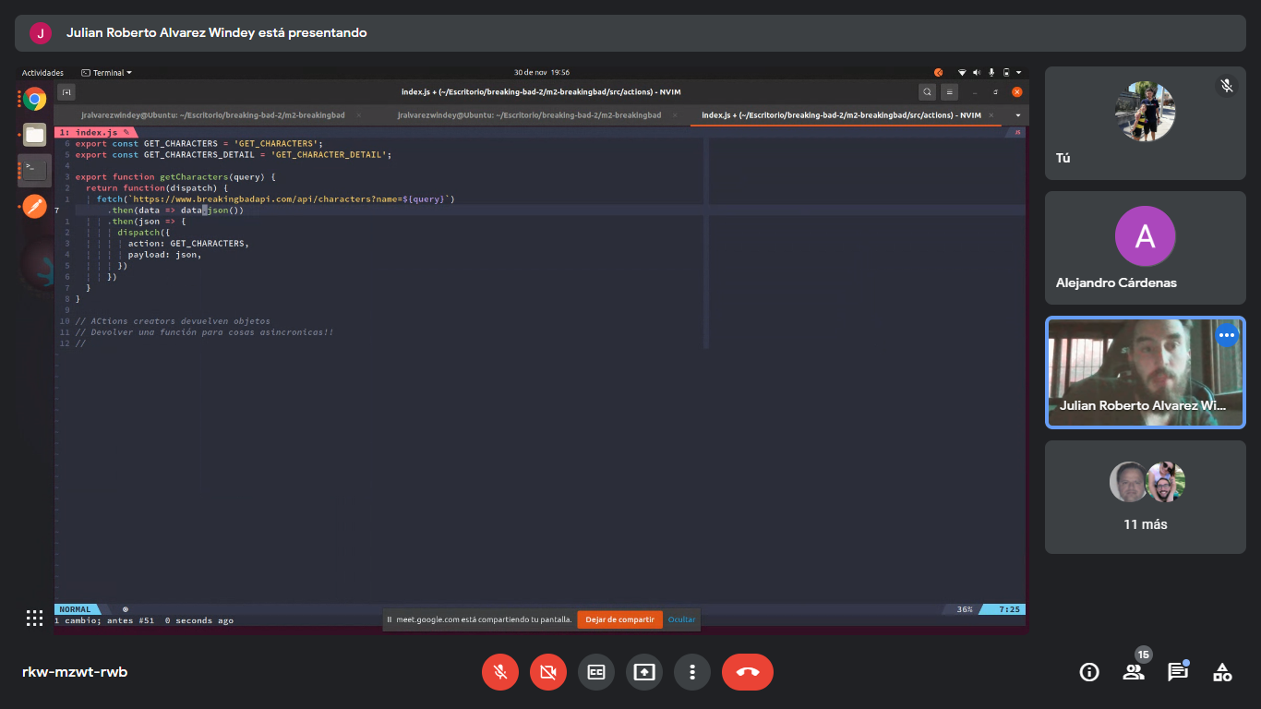

Con axios 🡨 hay que instalarlo previamente

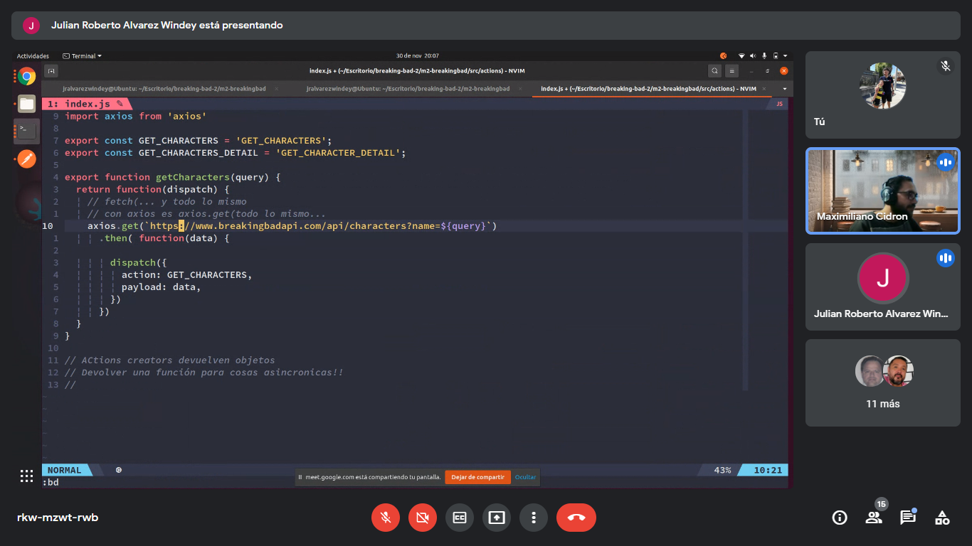

export const getCharacters = (query) => async (dispatch) => { const response = await axios.get(`[https://www.breakingbadapi.com/api/characters?name=${query}`](https://www.breakingbadapi.com/api/characters?name=$%7bquery%7d%60)); dispatch({ type: GET_CHARACTERS, payload: response.data, }); };

reducer … con index adentro

store… con index adentro

dentro de la carpeta reducer… modificamos el index

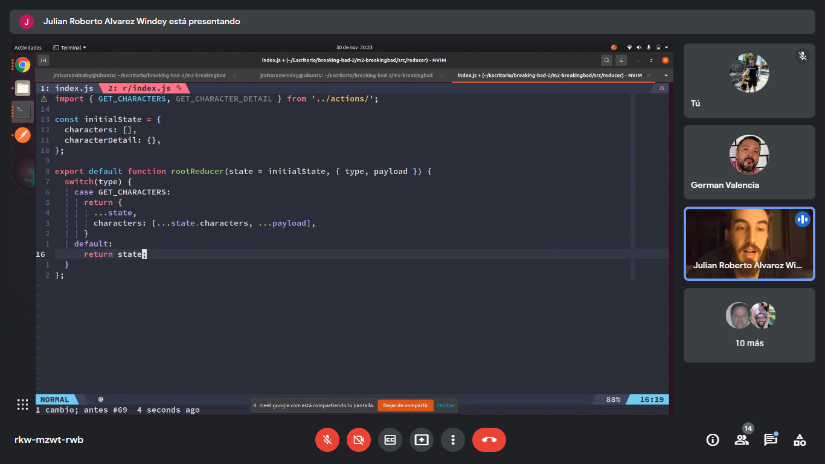

Carpeta sotre… index

